ATIC Accessibility
To support the accessible community in making informed travel decisions for their individual needs

This report prepared for:
Business name: | Dwellingup Adventures
Address: | 4 Marinup St
Town: | Dwellingup
Date: | 2024-02-13 18:57

ATIC Accessibility
The following pages provides travellers with information on the businesses facilities and amenities which aims to support the traveller to make an informed decision on whether the business is suitable for their individual needs.
OVERVIEW 4
Business Overview 4
Bookings 4
Emergency Management 4
Communications 5
Other Information 5
Guide Dog and Service Animals 5
GENERAL 6
Pre-arrival, arrival and reception 6
Cognitive Impairment Support 6
Car Park and Access amenities 6
Entry 7
Internal Spaces 7
Public areas 7
External Paths 7
Public Toilets/Adult change facilities 8
TOUR OPERATORS 9
Tour/Transport Services 9
Route Planning 9
Guides 9
COMMON AREAS 14
ADVENTURE ACTIVITIES 15
Report Disclaimer 16

OVERVIEW

Business Overview

The business has the following products/services available
- Tour/Transport
- Adventure

Our business caters for the following disability types:
- Blind or low vision
- Deaf or low hearing
- Limited mobility
- Wheelchairs or mobility scooters
- Food allergies or intolerances
- Cognitive or people on the Autism Spectrum

Bookings

The business offers the following methods for bookings and enquiries:
- Phone
- Email
- Webportal

Emergency Management
- There are Audible device/s to alert occupants to evacuate with instructions on how to evacuate.
- Exit signs are clear and easy to see
- Exit access is free and clear at all times
We ensure exit access is free and clear at all times by: Staff monitor area is clear as it is a legal requirement.
- Exits and access to exits are greater than 900mm
- Exit doors are able to be opened by all occupants
- Exits to the emergency evacuation point does not include stairways
- The evacuation point is clearly marked by a sign
The business identifies guests who need additional assistance should an emergency occur by: Through our internal notes on our booking system.
The procedure for assisting guests who need assisted rescue is: Staff direct customers in Retail space to exits. Internal emergency procedure applies.

Communications
- Our business offers the following alternative communication methods
- Plain English
- There is easy to read signage and information (e.g. menus and emergency information)
- There is a Pictorial menu
  - Pictorial Menu Image(s)
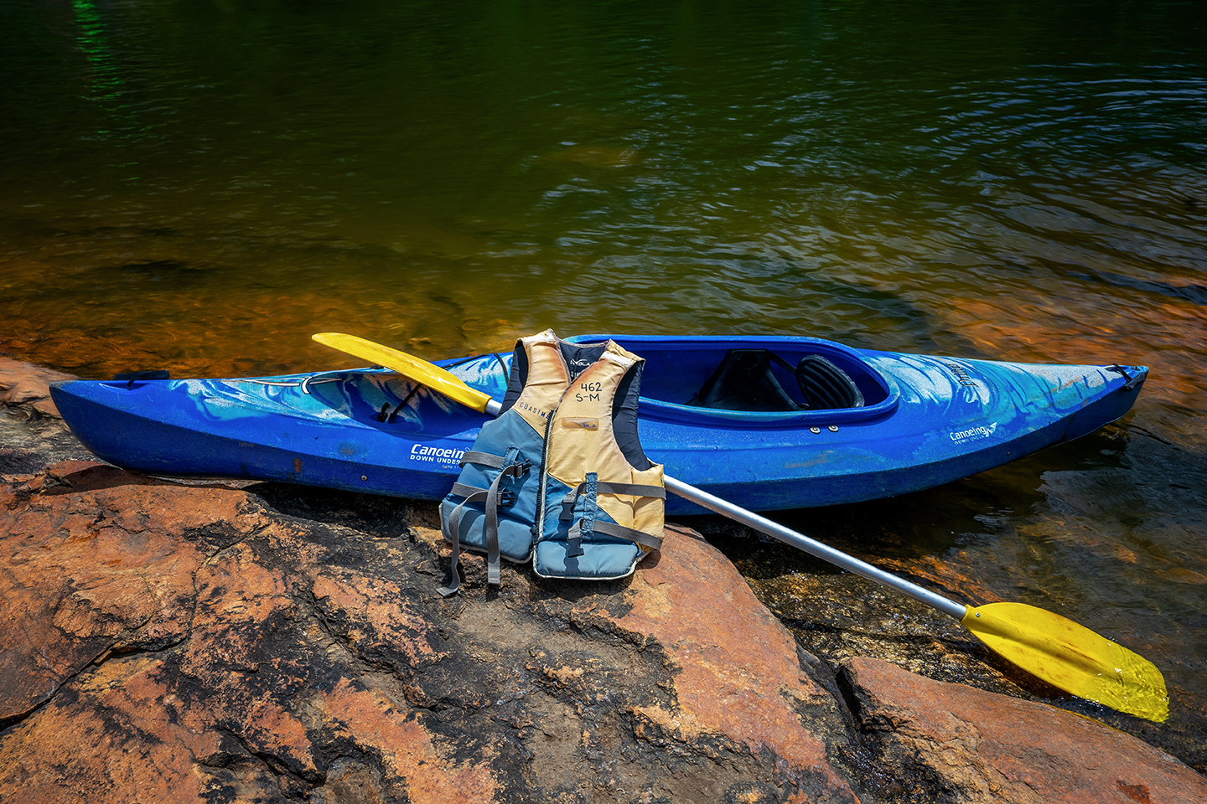
Products-watercraft-01-web

Other Information
- For bookings made onsite, the ticket booth/counter/box office is accessible for people using a wheelchair
- The business accepts the companion card

Guide Dog and Service Animals
- The business provides a secure area with shade and water for service animals
- The business provides a toilet area for service animals
- Bowls, bedding, etc. are provided for service animals
The business provides the following services for services animals: water bowls and water refill station, shaded area where dogs can be tied up.

GENERAL

Pre-arrival, arrival and reception
The business has the following in place to support guests during pre-arrival, arrival and reception
- There is a reception/public entryway.
- Seating available at reception
- A tablet with text to voice or pen and paper at reception to aid in communication
- Picture Board at reception to aid in communication
- Lighting in the reception area is even and glare free
- Large print information sheets and registration forms
- Information and maps are available in written form
- A familiarisation tour
no accessible facilities are locked.
The following steps are in place to ensure that people with fatigue related to their disability are not disadvantaged by long wait times: We have tables and chairs for people to sit at if they need to wait.

Cognitive Impairment Support
- Documents are available in plain English for people with cognitive impairment (This may include instructions, guides, menus and general information)
- Quiet periods or early opening times for people on the Autism Spectrum
- A space for parents and children on the Autism Spectrum

Car Park and Access amenities
The business has the following Car Park and Access amenities
- A drop off zone
- Designated disabled parking bays
- Level or ramped access from the car park to the entrance
- The accessible entrance is clearly signed from the parking bay
- Kerb ramps are in place where a pavement or walkway needs to be crossed

Entry
The business has the following amenities/systems in place for entry
- A drop off point close to the entrance
- A path of access to the building is slip resistance and even
- A path of access to the building is clear of obstruction
- Self opening entry doors or fitted with a self closer
- Door handles are of a contrasting colour to the door
- Signage is written in a contrasting colour
- Signage is written in a Sans Serif font and use upper and lower case letters
- The entry door is a minimum of 850mm wide
- The entry door has self opening or a light opening pressure (for manual operations)
- The entrance sill is less than 13mm
- There a clear space of at least 1500mm x 1500mm in front of all doors.
- In addition, the following further information can assist guests:
No entrance door mats at wheelchair access (main) entrance.

Internal Spaces
- Clear and unobstructed routes through and between buildings
- Interior walls are matte or low sheen
- Floors, walls, counters and furniture are of contrasting colours
- Floor surfaces are hard or short pile carpet
- Seating is available for guests unable to stand for long periods
- Accessible facilities are clearly signed and visible from all areas
- All corridors greater than 900mm
- There is a quiet space for parents and children on the Autism Spectrum

Public areas
The public areas have the following amenities in place
- Even lighting
- Seating

External Paths
External paths of travel have the following amenities are in place
- Surfaces are concrete, asphalt, smooth paving or hard packed fine gravel (max aggregate size 13mm)
- Paths or slopes longer than 15 metres have resting places or seats
- Pathways are wider than 900mm
There are no steps
- Step free routes clearly signed

Public Toilets/Adult change facilities
Public Toilets/Adult change facilities have the following amenities are in place
- There is an accessible toilet for public use
- The door is at least 850mm wide
- There is a minimum of 850mm beside the toilet
- Handrails are fitted
- The toilet seat is 460mm above the floor
- The toilet sits 6ft from sink in front of it and the room is 8ft wide. mm of clear space in front of the toilet
- The toilet seat of a contrasting colour to the floor

TOUR OPERATORS

Tour/Transport Services
The tour/transport services have the following facilities/amenities in place
- Busses/Coaches
- No vehicles have wheelchair lifts or ramps
- No vehicles have low floors with ramped entry
The maximum wheelchair capacity available in the fleet is: 0
- Commentary is available in written format

Route Planning
- Route Planning
- The tour route includes stops with accessible toilet facilities

Guides
- Use of clear/simple English
- Correct pronunciation for lip readers
  - Image(s)
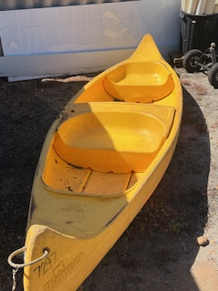
2 person Canoe
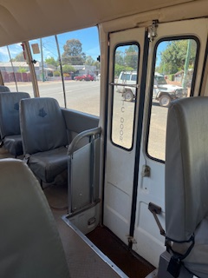
Bus door access
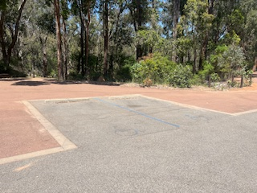
Disabled parking bays at Dwaarrlinjirraap
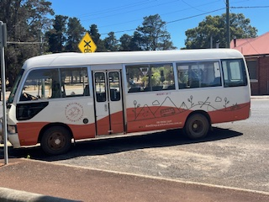
Dwellingup Adventures 21 Seater Bus
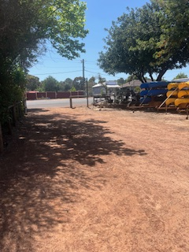
Dwellingup Adventures Hire Yard access
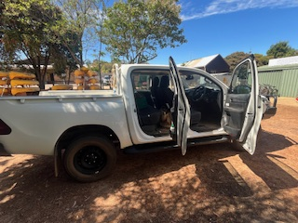
Hilux seating access
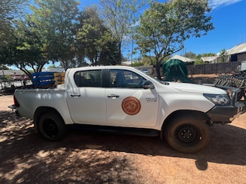
Hilux
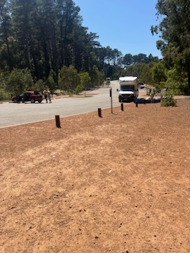
Hire drop off zone at Dwarrlindjirraap.
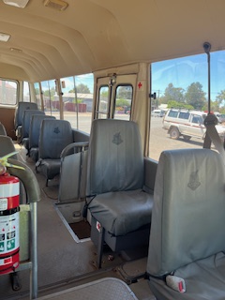
Interior bus seating plan
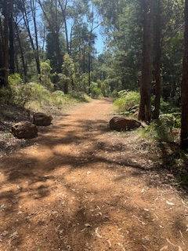
Ramp access to river
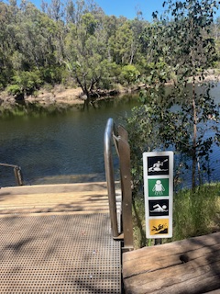
River access for boats has steps.

Report Disclaimer
Please note that this business report, provided as a result of the use of the diagnostic assessment, is for information purposes only.
Australian Tourism Industry Council (ATIC) cannot guarantee the accuracy of respondent’s answers, or that they are fully representative of your business. Therefore, ATIC does not warrant or guarantee any particular outcome in respect of your businesses self-assessment.
This report is intended as guidance only for your business and should not be relied on for future marketing considerations. ATIC recommends that you seek your own independent advice as well as the results from the diagnostic.
Links to external web sites are inserted for convenience and do not constitute endorsement of material at those sites, or any associated organisation, product or service.
ATIC does not:
- Assume any legal liability for the accuracy, completeness, or usefulness of any information from this report or any links provided; or
- Accept responsibility for any loss associated directly or indirectly from the use of this report

